Debugging Node.js applications

# (part 1)

As developers, we frequently spend a hefty mount of time debugging. It is for this reason that knowing how to properly debug is crucial if we want to be productive.

In this series we are going to kick the good old console.log out of our lives and learn how to debug node.js the right way.

# Fundamentals

Before we start we need to know that node.js uses the [Chrome V8 engine](https://developers.google.com/v8/)under the hood. The V8 engine is a low level piece of software written in C++ that translates our JS code to machine code.

The Chrome V8 engine implements a protocol called the V8 Inspector Protocol or Chrome Debugging Protocol. This protocol has been available since node 6.3 and it provides debugging clients with a way to communicate with the engine itself.

To demonstrate how we can debug a piece of code we are going to run a simple HTTP “Hello world” server in debug mode.

This is the code for the server:

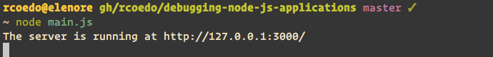

# The built-in node debugger

Many people don’t know it, but Node.js comes packed with it’s own debugging client. We can run the previous example in debug mode using the command node inspect:

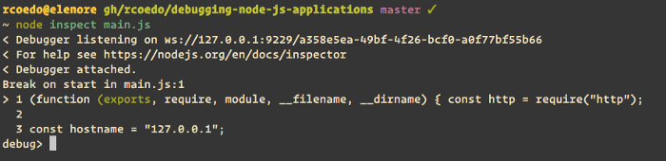

The code execution stops at the start of the script. The prompt changes to debug> and we can start typing some commands. Typing help will print a list with all the available commands.

Now we are going to set a breakpoint inside the request handler. We use the setBreakpoint function to set a breakpoint in the line 7. Then we use the cont function to let the code execution flow.

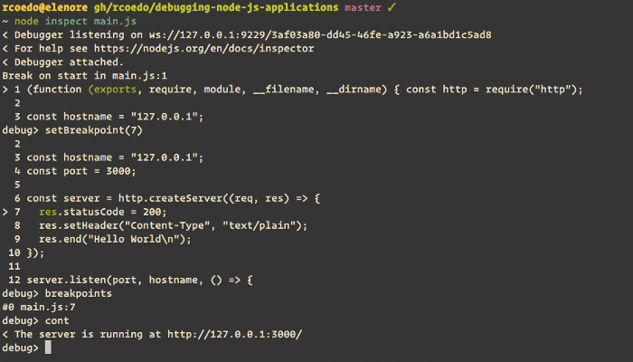

Now we can go to http://localhost:3000/ and the script will stop at the request handler. Once it stops we use the repl command to launch a REPL. This REPL will let you evaluate expressions in the current context.

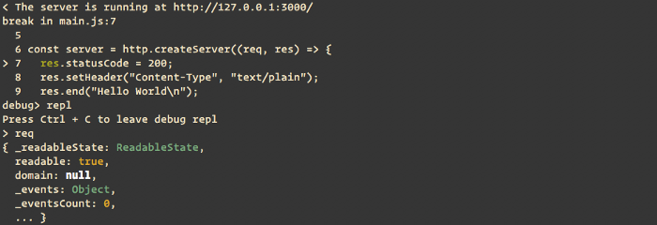

There are many other useful commands in the builtin inspector but we are not going to cover them here. The builtin debugger is nice when we need to do some quick debugging but there are better clients.

# Using third party debuggers

In our previous example we used node inspect to run our code. What this command does is tell node to run our code listening for inspector commands via websockets on ws://localhost:9229/, and then it runs the builtin debugging client connected to that socket.

We can use the --inspect or the --inspect-brk [CLI flag](https://nodejs.org/api/cli.html#cli_inspect_brk_host_port) to just run the code in debug mode and then use a third party debugger to attach to the inspector. The only difference between the two is that --inspect-brk stops the execution at the start of the script and the --inspect does not.

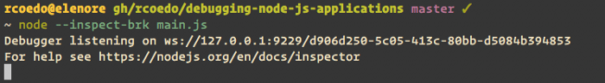

## Chrome Developer Tools

We can attach to the running process using the Chrome Developer Tools. With the debugger listening, go to chrome://inspect and you will see something like this:

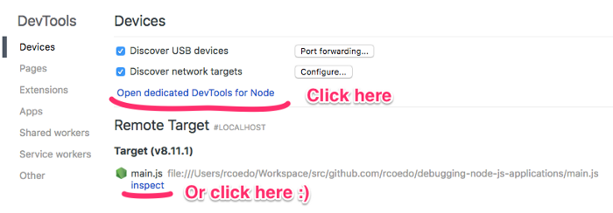

Clicking the link will open the Chrome Developer Tools window and automatically attach the debugger to the running process. We can do mostly the same things we could do with the builtin debugger but the interface is way better.

If you are using macOS, You can use [this small script](https://github.com/rcoedo/chrome-nodevtools) to open the node.js Chrome Developer Tools directly from the command line.

## Visual Studio Code

We could also use Visual Studio Code to attach to the node process. To do this, open your script with vscode, press SHIFT+CMD+P and type attach to node process. This will list all the processes you can attach to. Choose the process listening to port 9229 and you will be ready to debug.

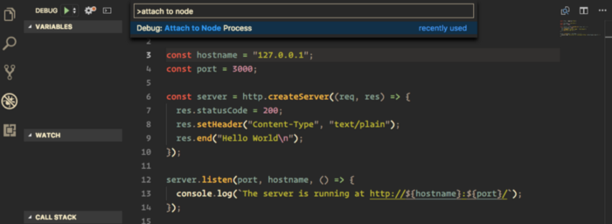

# Using ndb

[Ndb](https://github.com/GoogleChromeLabs/ndb) is a new node debugger done by Google. It uses [Puppeteer](https://pptr.dev/) to launch the Chrome Developer Tools, but has [some nice extra features](https://github.com/GoogleChromeLabs/ndb#what-can-i-do).

You can easily install ndb with npm or yarn:

$ npm i -g ndb  
$ yarn global add ndb

Once installed, just prepend ndb before the thing you want to debug and the Chrome Developer Tools will automatically open attached to the process:

$ ndb node main.js

# Wrapping it up

In this post we have learned how to attach our debugger to a node process. In the next part of this series we will cover the basics of the Chrome developer tools and we will use the debugger to fix a real bug.

# (part 2)

In the [first part](https://medium.com/trabe/debugging-node-js-applications-part-1-f1cca5084356) of this series we learned how debuggers work and how to attach our debugging client to our code. In this part we will cover the basic features of the chrome debugger.

# Breakpoints

A breakpoint is a mark you can place anywhere in your code to pause its execution. You can place it by clicking the line number in the chrome debugger, or alternatively, you could use the Javascript [debugger](https://developer.mozilla.org/en-US/docs/Web/JavaScript/Reference/Statements/debugger) statement anywhere in your code.



We can set breakpoints by clicking the code or using the **debugger** statement.

## Inline breakpoints

Let us say we have a file name in dash-case format and we want to drop the extension and convert it to camel-case:

// "my-file.js" => "myFile""my-file.js"  
 .replace(/\.[^/.]+$/, "")  
 .replace(/-([a-z0-9])/g, g => g[1].toUpperCase());

It is quite common in Javascript to chain calls in a single line like this. When we debug chained calls we usually want to watch what happens in every step of the chain. The default debugger, however, only allows breakpoints in whole lines.

More advanced debuggers like the chrome debugger have features that will allow us to set inline breakpoints. In the chrome debugger, when we set a breakpoint in a line that has more than one call there will be an arrow in front of each one indicating that we can break the execution down even further.

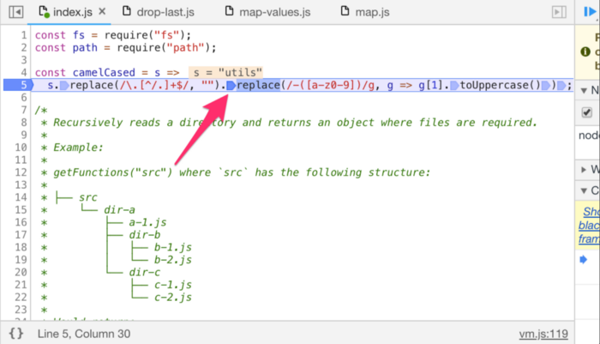

This is specially useful when we have a ternary operator and we want to stop in one of the statements:

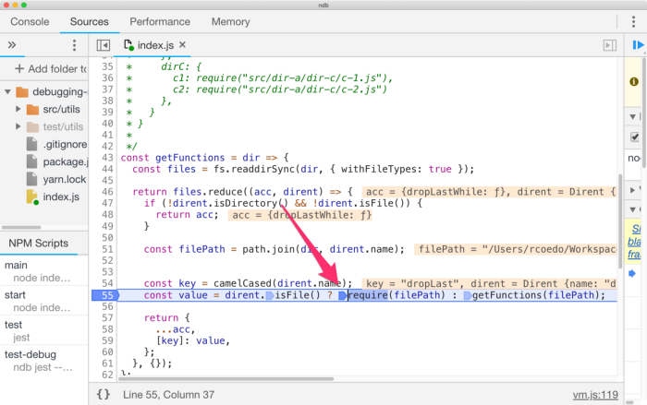

The execution pauses at the **require**

## Conditional breakpoints

A conditional breakpoint is a breakpoint that only stops the execution when a certain condition is met. This is specially useful when we are debugging loops and we need to stop on a specific scenario:



## Pausing on exceptions

We can tell the debugger to pause execution when an exception is thrown. By default the debugger will stop on uncaught exceptions only, but we can also choose to pause on caught exceptions if we need to.

We can activate this option using the button in the top-right menu:

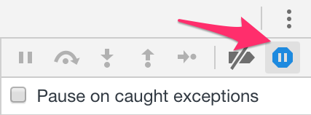

# Debugging tools

Once we are paused somewhere in the code there are several tools we can use to navigate and analyse it. The debugger will give us contextual information, including defined variables and their values and also the call stack.

## Stepping through our code

In the top-right menu we have controls to continue executing the code in different ways:

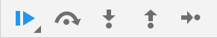

From left to right: Play, step-over, step-into, step-out and step.

* The “play” button will continue the execution until a new breakpoint is found or the program ends.
* The “step over” button will execute the next line of code, not stepping into function calls.
* The “step into” button will enter the current function call.
* The “step out” button will get you out of the current call in the call stack.
* The “step” button will execute the next line of code.

## The scope

In the right menu, we can find a section with the [scope](https://developer.mozilla.org/en-US/docs/Glossary/Scope). The scope is the context of execution of our code (everything that is defined) at that moment in time. We can use the scope to analyse what variables are defined and their values.

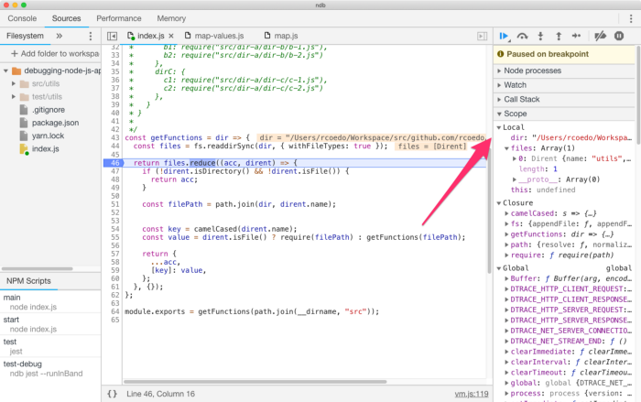

All defined variables will be listed here. We can check the [local scope](https://developer.mozilla.org/en-US/docs/Glossary/Local_scope), the [closured values](https://developer.mozilla.org/en-US/docs/Web/JavaScript/Closures) and the [global scope](https://developer.mozilla.org/en-US/docs/Glossary/Global_scope).

## Expression watching

One useful tool when debugging is expression watching. In the chrome debugger we can define a set of expressions that will be evaluated on the fly and their result will be shown. The cool thing is we can reference variables from the scope.



## The REPL

While paused, we can access the Javascript console to evaluate code in the current execution context. We can show and hide the console with the escape key.

This is probably the most flexible tool in the debugger client since we can do almost anything we want here. However, avoid using it only for expression watching. The expression watchers are still more efficient since you can define them once and use them in more than one execution.

## The call stack

In the right menu we can find the call stack section. We use this when we need to navigate the call stack to find why a function was invoked.

It is quite useful when used in conjunction with the “pause on exceptions” option. In this scenario the call stack will let us find which function call caused the exception.



## A word on blackboxing

When jumping around your code sometimes you end up in source files you are not interested in, like source files from your node_modules for instance.

Blackboxing allows you to ignore some scripts, so they will not show up when stepping through your code.

Some debuggers ignore the node_modules folder by default. You can choose to blackbox any script you like in the “Blackboxing” tab in the chrome debugger “Settings” panel.

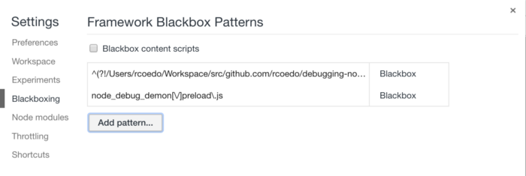

# Wrapping it up

These are the fundamentals of the chrome debugger. Master these tools and you will be able to find them pesky bugs in no time. Enjoy!